# xpedx.com Next generation

# *Customer and User Profile Design Document*

**Authors: Sterling Commerce**

**Date Created:** 04/28/10

**Last Updated:** 08/12/10

**File Name:** C:\Documents and Settings\bfurman\My Documents\Temp\Methodology v1.1\Project Management\TEMPLATE - DOCUMENT - Use Case Definition.docxpedx Customer And User Profile Detailed Design Doc V1 15.doc

Approval Signatures (Mandatory)

|  |  |  |  |  |
| --- | --- | --- | --- | --- |
| **Title** | **Name** | **Signature** | **Date** | **Comments / Issues / Concerns** |
| **xpedx Owner(s)** | Steve Bugher |  |  |  |
| Cheryl Tullis |  |  |  |
| **Sterling Commerce Owner(s)** | Guy Read |  |  |  |
|  |  |  |  |

**Note**: The sign off indicates approval of all sections of the document.

Document Revision History

This chart tracks the changes introduced by the revisions to the document as the project progresses through the stages of the System Development Life Cycle (SDLC).

| Version | **Date** | **Description (Changes Made)** | **Author(s)** |
| --- | --- | --- | --- |
| 1.0 | 04/28/2010 | Initial Draft | Sterling |
| 1.1 | 04/30/2010 | Ready to deliver | Sterling |
| 1.2 | 05/27/2010 | Feedbacks incorporated | Sterling |
| 1.3 | 06/04/2010 | Incorporated feedback from 6/1/10 meeting with George, Steve, Cheryl and Jasmine | Sterling |
| 1.4 | 06/08/2010 | Updated the document with the answer for the question below:  *When a user at a customer level logs in and selected a ship to for ordering, whose roles and value from the customer profile we will be checking*. Is it the customer (at which the user is logged in) or is the location for whom ordering is being done. For e.g Max Order Amount value, View Prices etc. Answer: If these values are overwritten at the ship to level, take those values else go to the parent. | Sterling |
| 1.5 | 07/01/2010 | More feedbacks | Sterling |
| 1.6 | 07/02/2010 | More feedbacks | Sterling |
| 1.7 | 07/12/2010 | Feedbacks incorporated | Sterling |
| 1.8 | 07/14/2010 | Added quick links, email preferences to user profile | Sterling |
| 1.9 | 07/26/2010 | Changes to reporting flag and added new T&A field | Sterling |
| 1.10 | 07/27/2010 | Added phone no, fax no, email address for invoice in user profile. Added email address for invoice in customer profile | Sterling |
| 1.11 | 07/29/2010 | Added additional flag for sales rep and csr order conf email | Sterling |
| 1.12 | 08/02/2010 | Added a JIRA open issue | Sterling |
| 1.13 | 08/03/2010 | Updates from Barry and George | Sterling |
| 1.14 | 0811/2010 | Last Login Added for user profile | Sterling |
| 1.15 | 08/12/2010 | Quick Links clarifications addefd | Sterling |

Related or Reference Documents

| Document Name | Description | Owner | Location |
| --- | --- | --- | --- |
| SCI_Xpedx Solution Definition Document v1.5 | Solution Definition document | Sterling Commerce |  |
| Xpedx Security Design Doc V1.0 | Design Document | Sterling Commerce |  |

TABLE OF CONTENTS

1. Introduction 5

1.1.1 Document Purpose 5

1.1.2 Document Audience 5

2 Customer and User Profile 6

2.1.1 Functions & Solution 6

2.1.2 Customer Profile 6

2.1.3 User Profile 23

2.1.4 Master System 27

2.1.5 Implementation Details 27

2.1.6 Entity objects. 27

2.1.7 Actions involved and Functions 27

2.1.8 API Details 27

2.1.9 Process Flow 27

2.1.10 Screen Shot 27

2.1.11 Open Questions 31

2.1.12 Assumptions 31

3 Glossary of Terms 33

# Introduction

## Document Purpose

This document is the governing functional design document for Customer & User Profile functionality. It presents significant decisions and constructs used in developing the functionality. Testing, builds, configuration management are not covered in this document.

The document will also serve the purpose of keeping a list of assumptions that were made during design discussions.

## Document Audience

This document is intended for management and technical staff working on this project, xpedx IT and Business, webMethods, Legacy(MAX and ACCESS), HP, IW, xpedx/IP Network Team. Sterling will use the document during design and configuration for design consideration.

# Customer and User Profile

## Functions & Solution

Customers are modeled as Buyer Organizations in Sterling, organization that purchases products from a storefront. After a customer is created, customer administrators belonging to that customer can view the details of that customer, update the details of that customer, create child customers, or update the details of the child customers.

If the customers / users are made inactive and then activated their data will not be lost, once active they can still access their carts, orders, my items list etc. Unless the customer / user is deleted their data will not be effected.

## Customer Profile

Rules for Managing Customers are defined by the customer hierarchy and role. Customer data is fed to Sterling through the Customer batch interface, but there are several attributes for the customer definition which are managed in Sterling. We call these attributes as Customer Profile attributes.

Typical Customer Hierarchy in xpedx is shown below.

The matrix below shows which fields are managed through which applications and customers.

|  |  |  |  |  |  |  |  |
| --- | --- | --- | --- | --- | --- | --- | --- |
| **Field** | **Web Channel** | **Call Center** | **Buyer Organization** | **Functionality** | **Inherit / Override** | **Comments** | **Data Source** |
| ~~Logo~~ | ~~Update~~ | ~~Update~~ | ~~Master Customer, Customer~~ | ~~Display on website header~~ | ~~Master to Ship To – cannot be overridden~~ | ~~Customers can upload their company logo in the customer profile page and see it on the home page when they log in.~~  ~~Don’t need this. We’re no longer allowing customers to show logos on the homepage.~~ | ~~Sterling~~ |
| Articles | Update | Update | Master Customer, Customer, Bill-To, Ship-To | Display articles and news on the home page | Master to Ship To – cannot be overridden | Customers can create the articles at the customer level. All the users belonging to the customer and child customers will see the articles when they login on the home page. If articles / news are created at the divisions, the users will also see those along with the ones created at the customer level. | Sterling |
| Can Request Sample | Not Applicable | Update | Master Customer, Customer, Bill-To, Ship-To | Sample Link  There will be only one link on the product detail page for sample. | Master to Ship To – can be overridden | Set the value to Yes for customers where the “service optimization code is K or P in the Customer Batch Feed.”  Set it to No for everybody else. On the product detail page, check the value for this field for a customer, if the value is blank, check for the service optimization code value from the customer batch for that customer and if it is K or P display the sample link if not do not display the link. | Sterling |
| ~~Sample form target email IDs~~ | ~~Update~~ | ~~Update~~ | ~~Master, Customer~~ |  | ~~Master to Ship To – cannot be overridden~~ | ~~Added per Samples DDD. A list of email addresses that will receive the sample form when submitted. Initially defaults to the Sales Rep associated with the customer. Available only if ‘Can Request Sample’ is YES. There is already a field for Sample Room Email Addresses – how is it different from that.?????~~ |  |
| Customer Email Address | Update | Update | Master Customer, Customer, Bill-To, Ship-To |  | Master to Ship To – can be overridden |  | Sterling |
| ~~Sample Room Email Address~~ | ~~Not Applicable~~ | ~~Update~~ |  |  | ~~Master to Ship To – can be overridden~~ | ~~Populated from Division Profile. This needs to be populated with the customer’s ship from division email address. The email address can be overwritten to a different email address per customer.~~ | ~~Sterling~~ |
| Buyer ID | Not Applicable | Update | Customer | Customer Solutions | Not Applicable | Only integration team can update | Sterling |
| WM Location ID | Not Applicable | Update | Customer | Customer Solutions | Not Applicable | Only integration team can update | Sterling |
| WM Org ID | Not Applicable | Update | Customer | Customer Solutions | Not Applicable | Only integration team can update | Sterling |
| eTrading ID | Not Applicable | Update | Bill-To, Ship-To | Customer Solutions | Not Applicable | Only integration team can update | Sterling |
| ~~eCSR1 (Name)~~  CSR1 (Name) | Read | Update | Master Customer, Customer, Bill-To, Ship-To |  | Master to Ship To – can be overridden | Only internal users can update. It will be a drop down of Internal User who has CSR role in the system. And they will be assigned manually from the drop down. This will be used for contact us and routing emails. If both eCSR1 and eCSR2 values are not populated, then the group (division) email address is fetched based on the customer’s ship from. | Sterling |
| ~~eCSR2 (Name)~~  eCSR2 (Name) | Read | Update | Master Customer, Customer, Bill-To, Ship-To |  | Master to Ship To – can be overridden | Only internal users can update. It will be a drop down of Internal User who has CSR role in the system. And they will be assigned manually from the drop down. This will be used for contact us and routing emails. If both eCSR1 and eCSR2 values are not populated, then the group (division) email address is fetched based on the customer’s ship from. | Sterling |
| Email Confirmation Flag – eCSR1 | NA | Read//Update | Bill To |  |  |  | Sterling |
| Email Confirmation Flag – eCSR2 | NA | Read//Update | Bill To |  |  |  | Sterling |
| ~~Industry~~  ~~Is this different from NACIS ID?~~ | ~~Read~~ | ~~Read~~ | ~~Master Customer, Customer (Confirm with Ryan/DW)~~ |  | ~~Master to Ship To – can be overridden~~ | ~~Populated via customer batch (This is the NAICS code – looks like a duplicate.)~~ | ~~Customer batch / Sterling~~ |
| Max Order Amount | NA | Update | Master Customer, Customer, Bill-To, Ship-To | Checked when an order is placed by the customer to see if the order is beyond the customer’s order limit. | Master to Ship To – can be overridden | Default is blank. There is max order amount set at the user level as well and that overwrites the value set at the customer level | Sterling |
| Min Order Amount | ~~Read~~  NA | Update | Master Customer, Customer, Bill-To, Ship-To | Checked when an order is placed by the customer to apply auto fee. | Master to Ship To – can be overridden | Default is blank. There is min order amount set at the user level as well and that overwrites the value set at the customer level. In case the order does not meet the minimum order value, a charge is added to the order as penalty. On the order if this value is blank, we need to look at the division value. | Sterling |
| ~~Charge Amount~~  On the screen it should display as “Small order fee” | ~~Read~~  NA | Update | Master Customer, Customer, Bill-To, Ship-To | This is the auto fee amount in case the order does not meet the min order amount | Master to Ship To – can be overridden | Default is blank  If the fee is not set at the customer level, then look at the field at the division level | Sterling |
| View Prices Flag | Not Applicable | Update | Master Customer, Customer, Bill-To | xpedx to define functionality | Master to Ship To – can be overridden  Can also be inherited to the user | Default is checked | Sterling |
| Can Order | Not Applicable | Update | Master Customer, Customer, Bill-To | xpedx to define functionality, especially how this is going to work with the buyer role at the user level. | Master to Ship To – can be overridden  Can also be inherited to the user | Default is checked | Sterling |
| View Inventory | Not Applicable | Update | Master Customer, Customer, Bill-To | xpedx to define functionality | Master to Ship To – can be overridden  Can also be inherited to the user | Default is checked | Sterling |
| Use Customer SKU | Not Applicable | Update | Master Customer, Customer, Bill-To |  | Master to Ship To – cannot be overridden | One field four fields (None, Customer SKU, Manufacturer SKU, MPC SKU) with radio buttons.  Not checking anything is None. By default nothing will be checked. | Sterling |
| Use Manufacturer SKU | Not Applicable | Update | Master Customer, Customer, Bill-To |  | Master to Ship To – cannot be overridden | Sterling |
| Use MPC SKU | Not Applicable | Update | Master Customer, Customer, Bill-To |  | Master to Ship To – cannot be overridden | Sterling |
| Use Order Multiple | Not Applicable | Update | Master Customer, Customer, Bill-To | This will be used to determine if Order multiple UOM needs to be the default UOM value in the drop down. | Master to Ship To – cannot be overridden | Default is checked | Sterling |
| ~~Can accept backorder~~ | ~~Not Applicable~~ | ~~Read.~~ | ~~Bill-To, Ship-To~~ |  | ~~Master to Ship To – cannot be overridden~~ | ~~Populated from customer batch. (Is this same as Ship Complete field from the customer load). Yes this is same as Ship Complete Flag.~~ | ~~Legacy via DW~~ |
| Invoice EDI | Not Applicable | Update | Master Customer, Customer, Bill-To | Customer Solutions | Master to Ship To – can be overridden | Default is unchecked | Sterling |
| View Invoices | Update | Update | Master Customer, Customer, Bill-To | xpedx to define functionality | Master to Ship To – can be overridden  Can also be inherited to the user | Default is not checked. It will be independent to the invoice distribution method. | Sterling |
| ~~Email Invoices~~  Invoice Distribution Method | Read | Read. | Bill-To, Ship-To | ~~I believe this is invoice preference – need to confirm.~~ | ~~Master to Ship To – can be overridden~~ | Populated from customer batch This is Invoice Distribution Method | Legacy via DW. |
| Customer Line Account Number | Read. Customer can update the label if the option is checked | Update | Master Customer, Customer, Bill-To, Ship-To |  | Master to Ship To – can be overridden | Default is unchecked. This checkbox field will be accompanied with a label text field to enter the label that shows up on the UI. | Sterling |
| Customer Line PO Number | NA | Update | Master Customer, Customer, Bill-To, Ship-To |  | Master to Ship To – can be overridden | Default is unchecked | Sterling |
| Customer Line Sequence Number | NA | Update | Master Customer, Customer, Bill-To, Ship-To |  | Master to Ship To – can be overridden | Default is unchecked | Sterling |
| Customer Line Field 1 | Read, Customer can update the label if the option is checked | Update | Master Customer, Customer, Bill-To, Ship-To |  | Master to Ship To – can be overridden | Default is unchecked; If checked, label is mandatory. This checkbox field will be accompanied with a label text field to enter the label that shows up on the UI | Sterling |
| Customer Line Field 2 | Read, Customer can update the label if the option is checked | Update | Master Customer, Customer, Bill-To, Ship-To |  | Master to Ship To – can be overridden | Default is unchecked; If checked, label is mandatory. This checkbox field will be accompanied with a label text field to enter the label that shows up on the UI | Sterling |
| Customer Line Field 3 | Read, Customer can update the label if the option is checked | Update | Master Customer, Customer, Bill-To, Ship-To |  | Master to Ship To – can be overridden | Default is unchecked; If checked, label is mandatory. This checkbox field will be accompanied with a label text field to enter the label that shows up on the UI | Sterling |
| Attention Name | Read | Read | Bill-To, Ship-To |  | Master to Ship To – can be overridden |  | Customer batch |
| LocationID | Read | Read | Bill-To, Ship-To |  |  |  | Customer Batch |
| Phone 1 | Read | Read | Bill-To, Ship-To |  | Master to Ship To – can be overridden | Default is blank; | CustomerBatch |
| Phone 2 | Update | Update | Master Customer, Customer, Bill-To, Ship-To |  | Master to Ship To – can be overridden | Default is blank; | Sterling |
| Fax 1 | Read | Read | Bill-To, Ship-To |  | Master to Ship To – can be overridden | Default is blank; | Customer Batch |
| Fax 2 | Update | Update | Master Customer, Customer, Bill-To, Ship-To |  | Master to Ship To – can be overridden | Default is blank; | Sterling |
| Order Dashboard Rules  (Rules are defined in the order Hold in Call Center DDD) | Not Applicable | Update | Master Customer, Customer, Bill-To, Ship-To |  | Master to Ship To – can be overridden |  | Sterling |
| Customer Division | Read | Read | Bill-To, Ship-To |  | Not applicable – defined at Bill To level |  | Populated via customer batch |
| Legacy Customer Number | Read | Read | Bill-To, Ship-To |  | Not applicable – defined at Bill To level |  | Populated via customer batch |
| Suffix Type | Read | Read | Bill-To, Ship-To |  | Not applicable – defined at Bill To or Ship-To level |  | Populated via customer batch |
| Suffix | Read | Read | Bill-To, Ship-To |  | Not applicable – defined at Bill To or Ship-To level |  | Populated via customer batch |
| ~~Bill to Suffix~~ | ~~Read~~ | ~~Read~~ | ~~Bill-To, Ship-To~~ |  | ~~Not applicable – defined at Bill To level~~ |  | ~~Populated via customer batch~~ |
| Customer Order Branch | NA | Read | Bill-To, Ship-To |  | Not applicable – defined at Bill To or Ship-To level |  | Populated via customer batch |
| Ship From Branch | NA | Read | Bill-To, Ship-To |  | Not applicable – defined at Bill To or Ship-To level |  | Populated via customer batch |
| Customer Status | NA | Read | Bill-To, Ship-To |  | Not applicable – defined at Bill To or Ship-To level |  | Populated via customer batch |
| Customer Name | Read | Read | Master Customer, Customer,  Bill-To, Ship-To |  | Not applicable – defined at Bill To or Ship-To level |  | Populated via customer batch |
| Address 1 | Read | Read | Bill-To, Ship-To |  | Not applicable – defined at Bill To or Ship-To level |  | Populated via customer batch |
| Address 2 | Read | Read | Bill-To, Ship-To |  | Not applicable – defined at Bill To or Ship-To level |  | Populated via customer batch |
| Address 3 | Read | Read | Bill-To, Ship-To |  | Not applicable – defined at Bill To or Ship-To level |  | Populated via customer batch |
| City | Read | Read | Bill-To, Ship-To |  | Not applicable – defined at Bill To or Ship-To level |  | Populated via customer batch |
| State | Read | Read | Bill-To, Ship-To |  | Not applicable – defined at Bill To or Ship-To level |  | Populated via customer batch |
| Country Code | Read | Read | Bill-To, Ship-To |  | Not applicable – defined at Bill To or Ship-To level |  | Populated via customer batch |
| ZipCode | Read | Read | Bill-To, Ship-To |  | Not applicable – defined at Bill To or Ship-To level |  | Populated via customer batch |
| Zip4 | Read | Read | Bill-To, Ship-To |  | Not applicable – defined at Bill To or Ship-To level |  | Populated via customer batch |
| Brand Code  (aka Territory Code) | NA | Read | Bill-To, Ship-To |  | Not applicable – defined at Bill To or Ship-To level |  | Populated via customer batch |
| Customer Class (Segment) | Read | Read | Bill-To, Ship-To |  | Not applicable – defined at Bill To or Ship-To level |  | Populated via customer batch |
| Service Optimization Code  (Customer Rank) | NA | Read | Bill-To, Ship-To |  | Not applicable – defined at Bill To or Ship-To level |  | Populated via customer batch |
| Currency Code | Read | Read | Bill-To, Ship-To |  | Not applicable – defined at Bill To or Ship-To level |  | Populated via customer batch |
| ~~National Account Number~~ | ~~Read~~ | ~~Read~~ | ~~Bill-To~~ |  | ~~Not applicable – defined at Bill To level~~ |  | ~~Populated via customer batch~~ |
| Customer (AKA SAP) Number | Read | Read | Customer |  | Not applicable – defined at Customer Level |  | Populated via customer batch |
| Customer (AKA SAP) Name | Read | Update | Customer |  | Not applicable – defined at Customer level |  | Populated via customer batch |
| Master Customer (AKA SAP Parent Account) Number | Read | Read | Master Customer |  | Not applicable – defined at Master Customer level |  | Populated via customer batch |
| Master Customer (AKA Parent SAP) Name | Read | Update | Master Customer |  | Not applicable – defined at Master Customer level |  | Populated via customer batch |
| Ship Complete | NA | Read | Bill-To, Ship-To |  | Not applicable – defined at Bill To or Ship-To level |  | Populated via customer batch |
| Order Update Flag | NA | Read | Bill-To, Ship-To |  | Not applicable – defined at Bill To or Ship-To level |  | Populated via customer batch |
| ~~CAPS ID~~ | ~~Read~~ | ~~Read~~ | ~~Bill-To, Ship-To~~ |  | ~~Not applicable – defined at Bill To level~~ |  | ~~Populated via customer batch~~ |
| Primary Sales Rep | Read | Read | Bill-To, Ship-To |  | Not applicable – defined at Bill To or Ship-To level |  | Populated via customer batch  Employee ID |
| Email Confirmation Flag - SalesRep | NA | Read//Update | Bill To |  |  |  | Sterling |
| Sales Rep 1 | Read | Read | Bill-To, Ship-To |  | Not applicable – defined at Bill To or Ship-To level |  | Populated via customer batch  Employee ID |
| Sales Rep 2 | Read | Read | Bill-To, Ship-To |  | Not applicable – defined at Bill To or Ship-To level |  | Populated via customer batch  Employee ID |
| Sales Rep 3 | Read | Read | Bill-To, Ship-To |  | Not applicable – defined at Bill To or Ship-To level |  | Populated via customer batch  Employee ID |
| Sales Rep 4 | Read | Read | Bill-To, Ship-To |  | Not applicable – defined at Bill To or Ship-To level |  | Populated via customer batch  Employee ID |
| NAICS Code | Read | Read | Master Customer, Customer, Bill-to, Ship-to |  | Master to Ship To – can be overridden |  | Populated via customer batch |
| NAICS Name | Read | Read | Master Customer, Customer, Bill-to, Ship-to |  | Not applicable – defined at Bill To level |  | Populated via customer batch |
| Ship To Override | NA | Read | Ship-To |  | Not applicable – defined at Bill To or Ship-To level |  | Populated via customer batch |
| PO Ack Flag | NA | Update |  |  |  | If this flag is checked that will be the trigger for Sterling to send the PO Ack/Order Update to WM | Sterling |
| ~~810 Invoice flag~~ | ~~Not Applicable~~ | ~~Update~~ |  |  |  | This is a duplicate of Invoice EDI flag |  |
| Email Address for Invoice | Update | Update | Update | Update |  | This field is used to store the email address that will be used by RRD to send invoices to this email address. |  |

## User Profile

Users are created for the customers and they purchase on behalf of the customers. Users are assigned to groups and groups have permission to actions that they are entitled to execute. Following are the user level fields that will be managed through the Sterling application:

The security document should outline the details of the roles.

|  |  |  |  |  |  |
| --- | --- | --- | --- | --- | --- |
|  | Web Channel (External Users) | | Call Center (Internal Users) | | Comments |
| Field | New User | Edit User | New User | Edit User |  |
| First Name | Update | Update | Update | Update |  |
| Last Name | Update | Update | Update | Update |  |
| Adress1 | Update | Update | Update | Update |  |
| Adress2 | Update | Update | Update | Update |  |
| Adress3 | Update | Update | Update | Update |  |
| City | Update | Update | Update | Update |  |
| State/Province | Update | Update | Update | Update |  |
| Country | Update | Update | Update | Update |  |
| Zip Code | Update | Update | Update | Update |  |
| Zip4 | Update | Update | Update | Update |  |
| Phone Number | Update | Update | Update | Update |  |
| Fax Number | Update | Update | Update | Update |  |
| UserId | Update | Read | Update | Read | CSR should be able to change the customer user’s user ID – Pawan: User ids in the system cannot be changed, if they want to create a new one they can, but they cannot change an exiting user’s userid or re-use it. |
| Password | Update | Update | Update | Update | User can only change their own password. CSR and Admin can only reset other user’s Password |
| Employee Id | NA | NA | Read | Read | Employee Id should be managed in LDAP and loaded during user migration. Should not be edited through Sterling. |
| User Type | NA | NA | Update | Read | Based on discussion with George, the system will set this value on a user record during creation, based on the user who is creating the user. If the user is being created by Security Admin, then mark the user type as internal users, otherwise user type is always external. |
| User Admin Role | Update (based on permission) | Update (based on permission) | Update (based on permission) | Update (based on permission) | Based on permission – meaning if the logged in user has the permission to the role. The following permissions are associated with this role.   1. Manage Users 2. View user carts for that customer 3. View orders for that customer 4. View reports for that customer 5. Manage My Items lists 6. Manage news |
| Buyer Role | Update  (based on permission) | Update  (based on permission) | Update (based on permission) | Update (based on permission) | Based on permission – meaning if the logged in user has the permission to the role. The following permissions are associated with this role.   1. Manage orders 2. View prices 3. View catalogs 4. Order History / Reporting 5. Returns 6. Manage their own MyItems list |
| Approver Role | Update  (based on permission) | Update  (based on permission) | Update (based on permission) | Update (based on permission) | Based on permission – meaning if the logged in user has the permission to the role. The following permissions are associated with this role.   1. All buyer functions as well as Manage Order for Accounts. |
| View Prices | Update  (based on permission) | Update  (based on permission) | Update (based on permission) | Update (based on permission) | If this flag is turned off, we will still do tha P&A but hide the price from showing it on the UI in web channel, COM |
| View Reports | Update  (based on permission) | Update  (based on permission) | Update (based on permission) | Update (based on permission) | If the View Prices flag is turned on, then check this field to either show the reporting link or not. |
| View Invoices Role | Update  (based on permission) | ~~Update~~  ~~(based on permission)~~  NA | Update (based on permission) | Update (based on permission) | Based on permission – meaning if the logged in user has the permission to the role. The following permissions are associated with this role.   1. View invoices online |
| Estimator Role | Update  (based on permission) | ~~Update~~  ~~(based on permission)~~  NA | Update (based on permission) | Update (based on permission) | Based on permission – meaning if the logged in user has the permission to the role. The following permissions are associated with this role.   1. View Prices 2. View Catalogs 3. Create Cart 4. View Order History / Reporting 5. Cannot checkout |
| Stock check webservice Role | ~~Update~~  ~~(based on permission)~~ NA | ~~Update~~  ~~(based on permission)~~  NA | Update (based on permission) | Update (based on permission) | Based on permission – meaning if the logged in user has the permission to the role. The following permissions are associated with this role. This role will be checked when somebody requests a stock check and will be allowed if the user has this role. |
| Min Order Amount | NA | NA | Update | Update |  |
| Max Order Amount | NA | NA | Update | Update |  |
| User Email Address | Update | Update | Update | Update |  |
| Additional Email Address | Update | Update | Update | Update | The additional email addresses will be used to send order confirmation emails along with the user’s email address. This could be more than one e-mail address. This will be maintaining list from the checkout. |
| Email Address for Invoice | Update | Update | Update | Update | This field is used to store the email address that will be used by RRD to send invoices to this email address. |
| PO List | Update | Update | Update | Update | PO List is a reusable list of PO #s that the user wants to reuse on orders. |
| ~~Receive Order Confirmation~~ Email Format | Update | Update | Update | Update | Options are   * HTML - Default * Text |
| Preferred Catalog | Update | Update | Update | Update |  |
| Assigned customer locations | ~~Read~~  Update for customer admin | ~~Read~~  Update for customer admin | Update | Update | This is the assignments of more than one accounts to a users, this is for security. Customer admin should be able to assign accounts through web channel. |
| Default Ship To | Update | Update | Update | Update | Need to define workflow as how the default value needs to be set in user profile. |
| Receive Order Confirmation Email Flag | Update | Update | Update | Update | This flag if checked for an user, an order confirmation will be sent out when order is placed. The event will be triggered after order placement response. Confirmation email will still be sent out if the transaction for transmitting the order to Legacy fails. |
| Receive Order Cancellation Email Flag | Update | Update | Update | Update | This flag indicates whether to send a order cancellation email to the user. Once the order cancel request is successful, this email will be sent out to the user confirming order has been cancelled. |
| Receive Order Update Email by CSR | Update | Update | Update | Update | This flag indicates whether to send a order update email to the user when order update is received from Legacy. Is this in scope???? |
| Receive Order Shipment Email | Update | Update | Update | Update | This flag indicates whether to send a order shipment email to the user, When order status is updated to Shipped in the order update message to Sterling. |
| Receive Backorder Email | Update | Update | Update | Update | This flag indicates whether to send a backorder email notification to the user, When order status is updated to BackOrdered in the order update message to Sterling. |
| ~~Pending Approval Email notification~~ | ~~Update~~ | ~~Update~~ | ~~Update~~ | ~~Update~~ | ~~What is this?? OOTB this is a system setting and not a profile setting. Let’s review.~~ |
| ~~Order Approved Email~~ | ~~Update~~ | ~~Update~~ | ~~Update~~ | ~~Update~~ | ~~What is this?? OOTB this is a system setting and not a profile setting. Let’s review.~~ |
| ~~Order Rejected Email~~ | ~~Update~~ | ~~Update~~ | ~~Update~~ | ~~Update~~ | ~~What is this?? OOTB this is a system setting and not a profile setting. Let’s review.~~ |
| ~~Order Changed / Approved Email~~ | ~~Update~~ | ~~Update~~ | ~~Update~~ | ~~Update~~ | ~~What is this?~~ |
| ~~Receive Marketing Emails from supplier~~ | Update | Update | Update | Update | Who is responsible to send this email?? I mean which system |
| ~~Receive Advertising Emails from Supplier~~ | Update | Update | Update | Update | Who is responsible to send this email?? I mean which system |
| Manage Quick Links | Update | Update | Update | Update | This will be a hang off table to user profile table which will store the following:  Show Link flag –  Link Name –  Link URL –  Link Sequence –  Created By –  These links will appear in the home page when the user logs in based on the user profile quick links which are marked to be shown. The users can only edit the links they have added, they can edit or delete the ones added by the buyer admin. |
| Accept TandC | NA | NA | Read | Read | This is a flag which needs to be set programmatically for forcing the users to accept terms and conditions first time they login. This needs to be implemented after successful authentication. |
| Last Login Date | NA | NA | Read | Read | This is for xpedx to delete any users who has not logged on in x amount of days. There is no workflow in Sterling for deleting users. |
| ~~B2B~~ Preferred Catalog View | Update | Update | Update | Update | Options are:  **Classic View – 1 item per row  **Classic View – 4 items per row  **Classic View – 2 items per row  **Matrix View – No images |

## Quick Links

1. Link Types: Links will be available in Storefront (all users under a storefront), Customer (all users under a customer – a level above bill-to) and Personal (applies only to that user) levels.
2. Adding/Editing/Deleting links:
   1. CSR can add/edit/delete Storefront and Customer links via Call Center.
   2. Customer Admin can add/edit/delete customer links via Customer Profile in Web Channel and add/edit/delete their own personal link via User Profile in Web Channel.
   3. Customer Buyer can add/edit/delete their own personal link via User Profile in Web Channel.
3. Default on new links: By default, any new Storefront and Customer links will be automatically added to User Profile with the ‘show’ box checked.
4. Sequence: When it comes to sequencing… to avoid complexity, George and PG discussed settled on this option.
   1. Separate (not from UI perspective) the quick links in three sections.

Current design states something like..

P My News

C Contract List

P My Mail

S Reports

C Company Contacts

S Invoice

*Where P - personal link; C - customer links; S - storefront links. Rather than mixing all types of links in a sequence, the recommendation is to sequence them by sections, something like… (you can decide if it should be P, C, S or S, C, P or whatever).*

P1 My News

P2 My Mail

C1 Contract List

C2 Company Contacts

S1 Reports

S2 Invoice

* 1. Manage the sequence ***and ‘show’ (Check Box)***  in respective profile.
     1. Storefront link sequence ***and ‘show’ (Check Box)*** will be maintained in ‘Storefront Profile’ (not sure what it is called in Call Center).
     2. Customer link sequence ***and ‘show’ (Check Box)*** will be maintained in ‘Customer Profile’.
     3. Personal link sequence ***and ‘show’ (Check Box)*** will be maintained in ‘User Profile’.

** Customer buyer cannot control the sequence ***or ‘Show’ (Check Box)*** of Storefront or Customer links

## Master System

Sterling is the master for all User profile data and the above listed Customer profile fields. There are other customer profile fields for which Legacy is the master of record and they will be periodically loaded in Sterling through a batch interface program.

## Implementation Details

## Entity objects.

* XPEDX_YFS_CUSTOMER_EXTENSIONS.xml
* XPEDX_YFS_USER_EXTENSIONS.xml

## Actions involved and Functions

Following new Actions are introduced to achieve the required functionality on top of OOTB

* XPEDXCustomerAssignmentAction.java
* XPEDXGetCustomerOrganizationAction.java
* XPEDXSaveNewUserInfoValidation.java
* XPEDXSaveUserInfo.java
* XPEDXSaveUserInfoValidation.java
* XPEDXUserGeneralInfo.java

## API Details

Following APIs will be called to achieve the functionality.

* getCustomerDetails – This API returns the customer details.
* manageCustomer - This API is called to modify, create or delete customer record.
* getCustomerContactList – This API is called to return a list of users matching the search criteria.
* getCustomerList – This API is called to display the list of child organizations.

## Process Flow

Not Applicable

## Screen Shot

The screen shots pasted here are still in review and not final. This is just an illustration of how it should look like.

***Customer Profile – Fields ….***

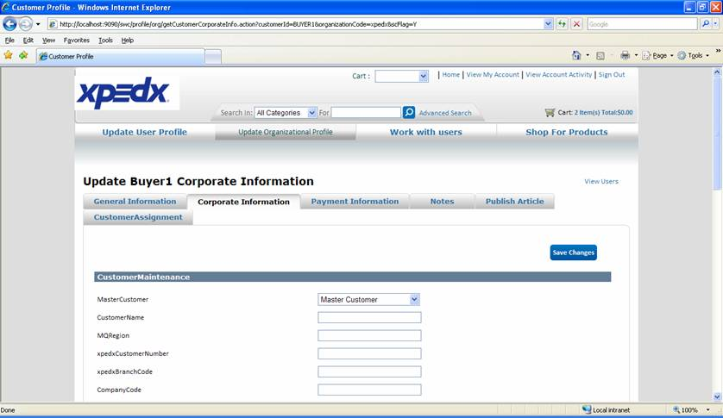

***Customer Profile – Fields ….***

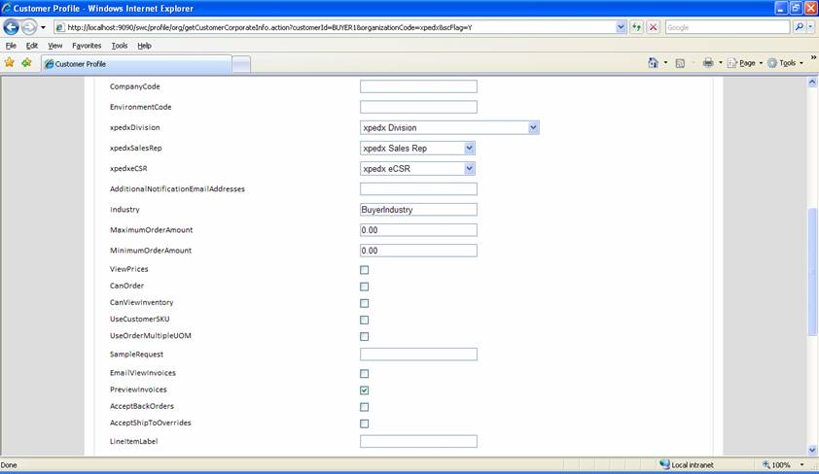

***Customer Profile – Fields***

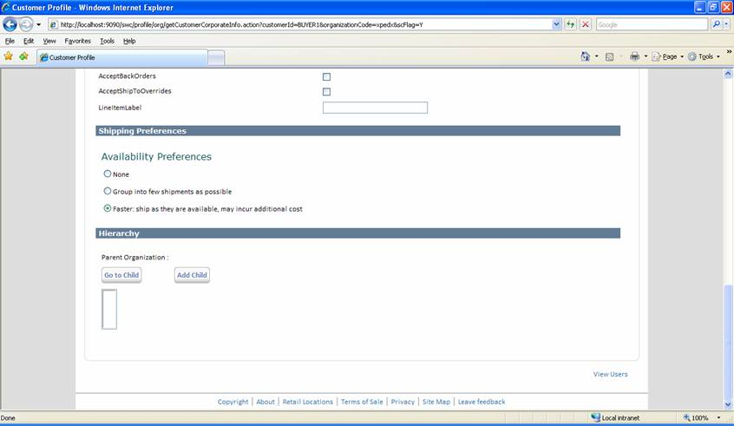

***Customer Profile: News/ Articles management***

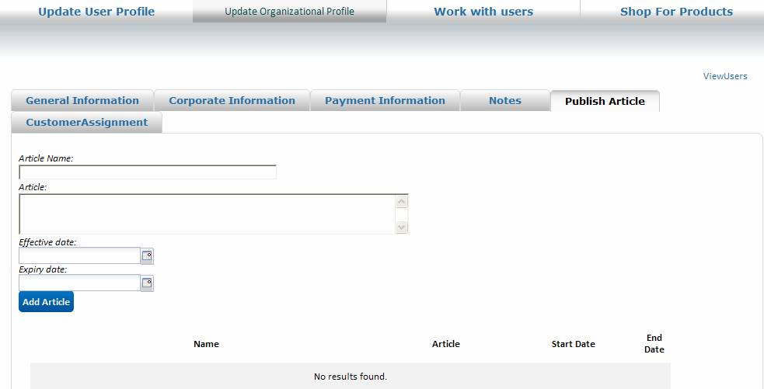

***Customer Profile: Customer Assignments***

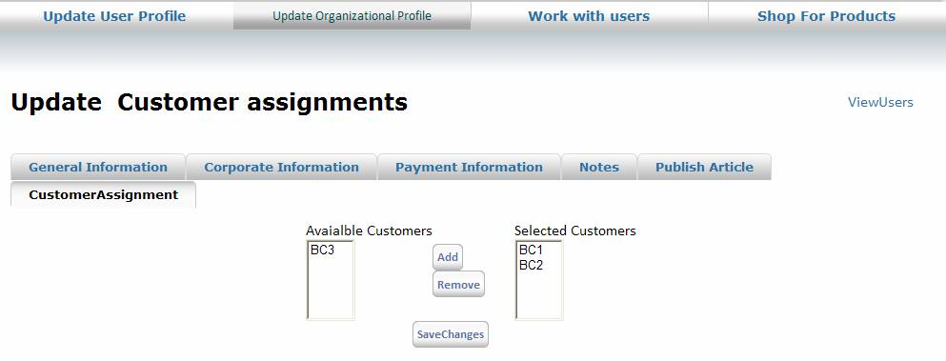

***Customer Profile: Customer Logo***

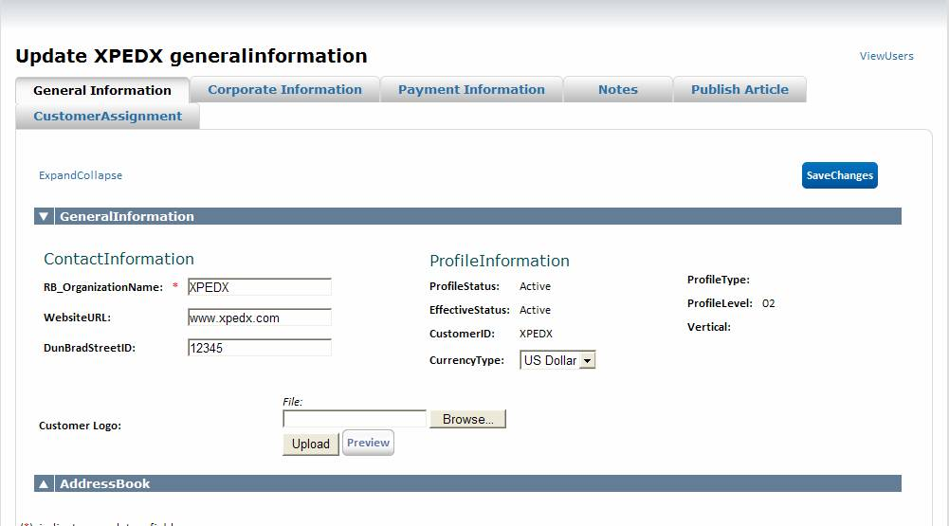

## Open Questions

1. *E-Trading ID*: Does it need to have a separate administration screen like current dotcom or can it be a field in the customer profile. Answer: Can be a field in the within the customer profile and no separate screen is needed.
2. *eCSR:* Whereis the list populated from?? Is it the list of all the available CSRs in the system? *Answer: Yes, it will be manually added, would include all CSR users.*
3. *View Prices Flag*: This is a buyer role for a user – why do we need this flag at the customer level. Answer: Should be able to handle at the customer level.
4. *Can Order* : This is a buyer role for a user – why do we need this flag at the customer level. Answer: Should be able to handle at the customer level.
5. *Max Order Value*: If the order value is beyond the max order value, do we hold the order? What should be the business flow for this situation? Answer: Force a hard halt that order cannot be placed.
6. *When a user at a customer level logs in and selected a ship to for ordering, whose roles and value from the customer profile we will be checking*. Is it the customer (at which the user is logged in) or is the location for whom ordering is being done. For e.g Max Order Amount value, View Prices etc. Answer: If these values are overwritten at the ship to level, take those values else go to the parent.
7. *Field length for Invoice Email address needs* to be decided. xpedx will look at RRD to see if there is any limitation and that Sterling needs to create multiple fields for the same. Please refer to JIRA – 349 for details.

## Assumptions

1. Customer profile fields coming as part of the batch interface will not be allowed to be modified in Sterling. Answer: According to the matrix above.
2. Based on the hierarchy of the logged in user and his permission he should be able to manage the customer and user profile for the child users.
3. Internal Roles and Users are mentioned in the Site Admin DDD.
4. Dashboard rules will be defined as part of the customer profile in COM. It probably will be a link from the customer profile to manage the rules.

# Glossary of Terms

|  |  |  |
| --- | --- | --- |
| S. No. | Term | Definition |
| 1. | Entity Object | Database and Java entity objects to store the required data. |
| 2. | Action Class | Struts controllers which redirects the parameters and does some business logic before calling the business APIs. |
| 3. | BR1 | Business Release 1 |
| 4. | IW | Industrial Wisdom – UI firm engaged on the project. |
|  |  |  |